Data Analytics Graduate Capstone-:
Paris Housing Prediction

TASK 3: Presentation of Findings

Student Name: Nikki Shrestha
Id No.: 010756950
Mentor: Daniel Smith
Date: 07/24/2023

- Executive Summary and Implications
- A statement of the problem and the hypothesis:
Our research question “To what extent the variables such as number of rooms, has pool, has storm protector, basement etc statistically significant to predict the price of the house?”
Alternate Hypothesis-
Variables are statistically significant to predict the price of the house.
- A summary of the data-analysis process:
I found the dataset on Kaggle.com which is publicly available. The dataset contains 10,000 records where the total number of columns is 17. The dataset will be downloaded from Kaggle.com in .CSV format and then cleaned and prepared using python packages for further analysis.
Steps to prepare data:
- Import dataset to Pandas dataframe.
- Read the data set into Python using Pandas read_csv command.
- Name the data set as "df_paris" and display the dirst five rows of the dataset.
- Get a description, structure and data types of the dataframe.
- Check for the duplicate data using .duplicated() function.
- Identify missing data or NaN using isnull() function and impute the missing data with the appropriate measures of central tendency (mean, median, mode).
- Drop less meaningful columns from dataframe.
- View summary statistics.
- Check for the outlier’s using histogram or boxplot.
- Create scatterplot to see the correlations between target and independent variables.
- Create the correlation plot and found there is direct linear relationship between price and squareMeter.
- Finally, the prepared dataset will be extracted & saved as "prepared_paris.csv" for further analysis.
- Next I created Multiple Regression techniques for this analysis. I also used the Ordinary Least Squares regression (OLS) model for estimating coefficients of linear regression equation which describe the relationship between one or more independent variables and dependent variable price.

- Outline of Findings:
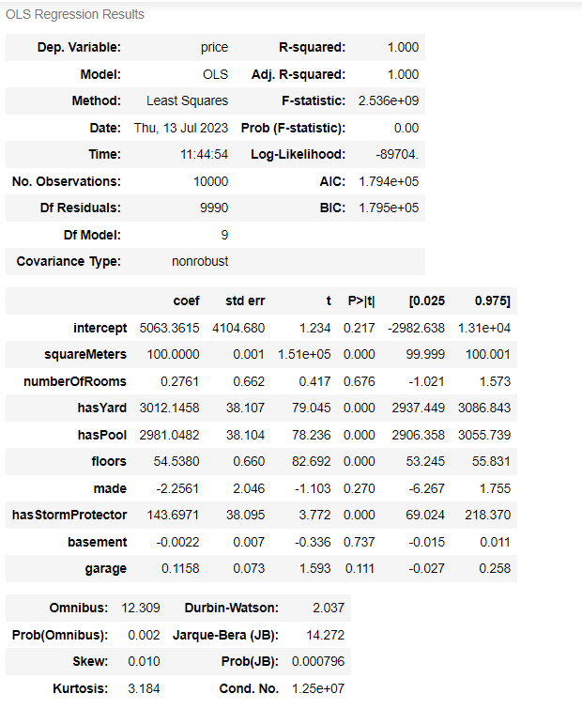
- The value of R2 is 1.00. So, 100% of the variation is explained by this model. The condition number is large which might suggest strong multicolinnearity. So we don't need all the variables to explain the variance. So now i reduce variables and run a multiple linear regression model on those variables with p - value 0.05 or less.
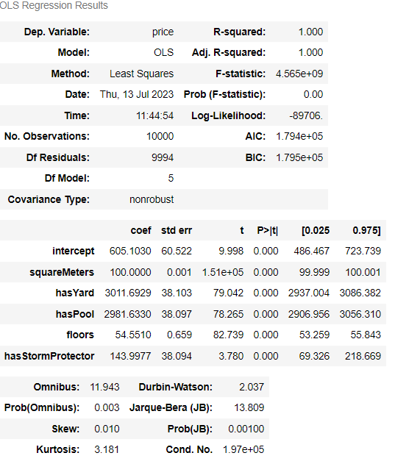

- After removing all the other predictor variables, the model still explains 100% of the variance.

- An explanation of the limitations of the techniques and tools used:

Python is use to support the various phases of the analysis. The disadvantage of Python is that it is a high-level programming language that can be slower than other languages when it comes to execution.
Multiple Regression techniques is use to create model. I use the Ordinary Least Squares regression (OLS) model for estimating coefficients of linear regression equation which describe the relationship between one or more independent variables and dependent variable price.
One of the disadvantages of multiple regression is it is sensitive to outliers, and prominent observations, which can misrepresent the regression line and affect the parameter values.
- A summary of proposed actions:
with such a direct linear relationship between price and squareMeters with Paris housing price prediction, it makes a logical sense to suggest the size of the property matters more than the other variables. I also think that more past data is needed as we don't know when the data was collected. To provide clear understanding, more investigation is required to get more accurate result.
- Expected benefits of the study:
Identification of important independent variables.
Prediction and forecasting.
Better detection tools.

- Presentation of Findings:

Mon Jul 24 2023 11:11:43 PM (panopto.com)

- Sources:
Tavish Aggarwal. (June, 2020). Limitations of the Linear Regression. Retrieved from https://www.techladder.in/article/limitations-linear-regression
What are the advantages and disadvantages of using multiple regression for quantitative analysis? (n.d). Retrieved from https://www.linkedin.com/advice/1/what-advantages-disadvantages-using-6c
Ken Feldman. (March, 2023). Step-by-Step Guide to Understanding and Using Multiple Regression in Your Research - isixsigma.com

